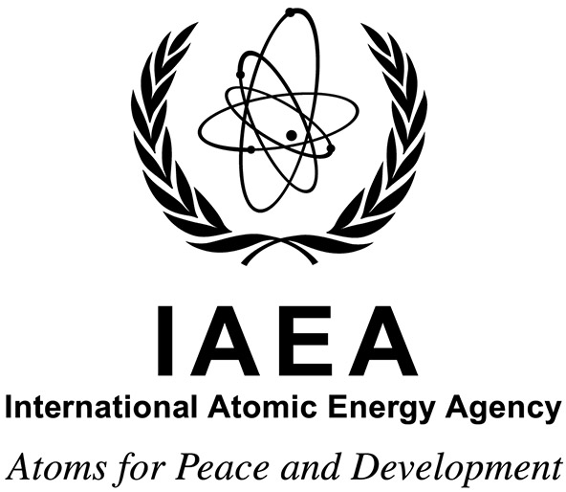

Virtual Workshop on Radiation Technology for Industry and Environment

Hosted by
The International Atomic Energy Agency
IAEA Headquarters
Vienna, Austria

19 to 22 April 2021

Ref. No.: ME-RER1021- 2100510

Information Sheet

Purpose

The purpose of the event is to strengthen information and knowledge exchange, and foster cooperation among researchers, engineers, radiation facility operators and the coordinators of academic programmes in the radiation sciences and technologies, leading to a comprehensive review of the status of radiation technology in industry and environment. The workshop is expected to generate ideas that will form the basis of identifying future activities under TC regional projects and collaboration among the Member States in the area of radiation technologies.

Working Language(s)

The working language(s) of the event will be English.

Deadline for Nominations

Nominations received after 19 March 2021 will not be considered.

Project Background
Radiation processing exists in many European countries mainly for the sterilization of medical products and the production of advanced polymer materials. The planned further expansion of the European Union has increased trade, requiring strictly controlled radiation technologies through standardized quality control methods and procedures. The EU and national authorities introduced new standards and regulations related to health care products, pharmaceuticals, food treatment and further development in radiation processing. To support the MSs who operate industrial gamma and electron beam facilities to introduce the standards as well as to ensure the safe and efficient use of radiation processing technologies with proper quality control procedures, there have been several IAEA TC regional projects; RER/8/017 “Enhancing Quality Control Methods and Procedures for Radiation Technology” (2009-2011), RER/1/011 “Introducing and Harmonizing Standardized Quality Control Procedures for Radiation Technologies” (2012-2013), RER/1/017 “Using Advanced Radiation Technologies for Materials Processing (2016-2017), and RER/1/019 “Enhancing Standardized Radiation Technologies and Quality Control Procedures for Human Health, Safety, Cleaner Environment and Advanced Materials” which in particular supported harmonization of selected national standards with the international standards ISO 9001, ISO 13485 and ISO 11137, and implementation of product and process control measures, enforced by the EU and national laws and regulations. Building on these past efforts, RER1021 (2020-2023) continues supporting quality assurance which is vital for the successful implementation of radiation processing technologies, therefore the proper use of standardized dosimetry procedures, supported by dosimetry interlaboratory comparison exercises at both gamma and electron beam irradiation facilities is of basic importance.

Scope and Nature

The discovery of ionizing radiation and radioactive materials has led to dramatic advances in medical diagnosis and treatment, and they are used for a wide range of procedures in industry, agriculture, and research. Radioisotopes and other radiation technologies have been promoted for their merit in addressing important human needs such as improving food security through enhanced crop production, food safety and shelf life in a sustainable manner, better managing scarce fresh water resources, improving human health, improving industrial production and processes, preserving cultural heritages and protecting our environment. Radiation processing may result in a purer and uniform product, and radiation-induced reactions can be carried out at relatively low temperature, resulting in lower energy cost, less thermal damage to the system and product.
Therefore, this workshop covers the topics in adopting radiation-based techniques that support cleaner and safer industrial processes and for the compositional analysis of materials and objects, in applying radiation technology for advanced materials development, nanoscience and the processing of natural polymers into such products, as well as for the management of industrial and agricultural waste and effluents and the decontamination of biological agents.
The workshop will be held on (tentatively):
Monday 19 April 2021: 10:00-15:00 (Central European Summer Time)
Tuesday 20 April 2021: 10:00-15:00 (Central European Summer Time)
Wednesday 21 April 2021: 10:00-15:00 (Central European Summer Time)
Thursday 22 April 2021: 10:00-13:00 (Central European Summer Time)

Participation

The event is open to 80 participants from Member States.

Participants’ Qualifications and Experience

The participants should be involved in radiation sciences and technologies as researchers, engineers, facility operators, or coordinators of academic programmes from the RER1021 MSs. As this being a virtual event, it is also open for the Member States in other regions who could commit their participation considering the time differences. Participation of young researchers and engineers are highly recommended.

Application Procedure

Candidates wishing to apply for this event should follow the steps below:

- Access the InTouch+ home page (https://intouchplus.iaea.org) using the candidate’s existing Nucleus username and password. If the candidate is not a registered Nucleus user, she/he must create a Nucleus account (https://websso.iaea.org/IM/UserRegistrationPage.aspx) before proceeding with the event application process below.

- On the InTouch + platform, the candidate must:
  - Finalize or update her/his personal details, provide sufficient information to establish the required qualifications regarding education, language skills and work experience (‘Profile’ tab) and upload relevant supporting documents;
  - Search for the relevant technical cooperation event (EVT2100510) under the ‘My Eligible Events’ tab, answer the mandatory questions and lastly submit the application to the required authority.
NOTE: Completed applications need to be approved by the relevant national authority, i.e. the National Liaison Office, and submitted to the IAEA through the established official channels by the provided designation deadline.
For additional support on how to apply for an event, please refer to the InTouch+ Help page. Any issues or queries related to InTouch+ can be addressed to InTouchPlus.Contact-Point@iaea.org.
Should online application submission not be possible, candidates may download the nomination form for the meeting from the IAEA website.

Administrative and Financial Arrangements

Nominating authorities will be informed in due course of the names of the candidates who have been selected, and will at that time be informed of the procedure to be followed with regard to administrative and financial matters.

Selected participants who indicate their need, will receive financial support to contribute to the expenses of their costs for internet connection for the duration of the event in line with IAEA rules and procedures.

Disclaimer of Liability

The organizers of the event do not accept liability for the payment of any cost or compensation that may arise from damage to or loss of personal property, or from illness, injury, disability or death of a participant while he/she is travelling to and from or attending the course, and it is clearly understood that each Government, in approving his/her participation, undertakes responsibility for such coverage. Governments would be well advised to take out insurance against these risks.

The IAEA takes no responsibility for, and the provider of the virtual meeting services has represented and warranted that the Services shall not contain, and that no end user shall receive from the software used to hold the virtual meeting, any virus, worm, trap door, back door, timer, clock, counter or other limiting routine, instruction or design, or other malicious, illicit or similar unrequested code, including surveillance software or routines which may, or is designed to, permit access by any person, or on its own, to erase, or otherwise harm or modify any data or any system, server, facility or other infrastructure of any end user (collectively, a “Disabling Code”).

IAEA Contacts

Programme Management Officer (responsible for substantive matters):
Ms Tomoko Furusawa
Division for Europe
Department of Technical Cooperation
International Atomic Energy Agency
Vienna International Centre
PO Box 100
1400 VIENNA
AUSTRIA
Tel.: +43 1 2600 22992
Fax: +43 1 26007
Email: T.Furusawa@iaea.org

Administrative Contact (responsible for administrative matters):
Ms Zuzana Svakova
Division for Europe
Department of Technical Cooperation
International Atomic Energy Agency
Vienna International Centre
PO Box 100
1400 VIENNA
AUSTRIA
Tel.: +43 1 2600 22395
Fax: +43 1 22395
Email: Z.Svakova@iaea.org

