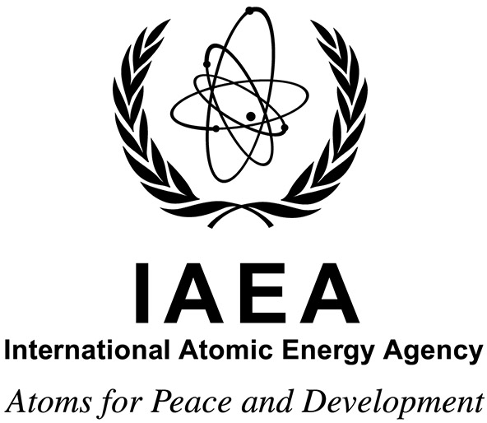

Virtual Interregional Training Course on Targeted Radionuclide Therapies

in collaboration with the Argonne National Laboratory (ANL), Argonne, Illinois, USA, and MD Anderson Cancer Centre, Huston, Texas, USA

23 August to 3 September 2021

Ref. No.: TN-INT6061- 2100590

Information Sheet
Purpose
The purpose of the event is to train experienced nuclear medicine physicians and nuclear medicine physicists with consolidated approach in therapeutic nuclear medicine so that they will acquire skills and competences which will enable them to enhance their practices.

Working Language
The working language of the event will be English.

Deadline for Nominations
Nominations received after 31 May 2021 will not be considered.

Project Background
The interregional training course covers the fundamental principles and application of therapeutic nuclear medicine, specifically, nuclear medicine techniques in the treatment of thyroid cancer, prostate cancer and other cancer types. These lectures should provide theoretical grounding in the improvement of nuclear medicine services. The experts will discuss the clinical utility and relative value with emphasis on the protocols to be used in the above conditions which will be one of the core learning points of this interregional training course. Lectures and interactive discussion sessions covering approaches in Targeted Radionuclide Therapy from streamlined and emerging approaches should provide theoretical grounding in the improvement of therapeutic nuclear medicine services to achieve the following:
a) Review the different established and emerging therapeutic nuclear medicine protocols and nuclear techniques in the evaluation and management of thyroid cancer, prostate cancer and other cancer types using I-131 and other radiopharmaceuticals.
b) Comprehensive knowledge of epidemiology, causes, risk factors, clinical manifestations/symptoms in thyroid cancer, prostate cancer, and others.
c) Differentiate and analyse the different protocols used in therapeutic nuclear medicine procedures including the role of hybrid imaging.
d) Explore the role of targeted radionuclide therapies into the clinical practice in IAEA Member States.
e) Comprehensive knowledge of the different medical physicists aspects of targeted radionuclide therapy, including but not limited to internal dosimetry, radiation safety, quantification, advances in gamma camera SPECT/CT systems and PET/CT imaging, accreditation of PET systems and Quality Assurance and Quality Control.

Scope and Nature
The virtual interregional training course consists of lectures and interactive discussion sessions on the
different aspects involved in Targeted Radionuclide Therapy.
The expected output is that participants will gain knowledge on the importance of targeted radionuclide therapies as a way to continuously improve the effectiveness and efficiency in a nuclear medicine department, understanding the different aspects involved in carrying out these therapies, and how to conduct them in a highly professional manner.

Participation
The interregional training course is open to 30 participants from countries in Africa, Asia and the Pacific, Europe and Latin America and the Caribbean. Each Member State may submit up to two
nominations.
Participants’ Qualifications and Experience
The nominees should be qualified nuclear medicine physicians or nuclear medicine physicists, with background in therapeutic nuclear medicine applications.
As the interregional training course will be conducted in English, participants should have sufficient proficiency to follow lectures and express themselves in this language without difficulty.

Application Procedure
Candidates wishing to apply for this event should follow the steps below:
- Access the InTouch+ home page (https://intouchplus.iaea.org) using the candidate’s existing Nucleus username and password. If the candidate is not a registered Nucleus user, she/he must create a Nucleus account (https://websso.iaea.org/IM/UserRegistrationPage.aspx) before proceeding with the event application process below.
- On the InTouch + platform, the candidate must:
- Finalize or update her/his personal details, provide sufficient information to establish the required qualifications regarding education, language skills and work experience (‘Profile’ tab) and upload relevant supporting documents;
- Search for the relevant technical cooperation event (EVT2100590) under the ‘My Eligible Events’ tab, answer the mandatory questions and lastly submit the application to the required authority.
NOTE: Completed applications need to be approved by the relevant national authority, i.e. the National Liaison Office, and submitted to the IAEA through the established official channels by the provided designation deadline.
For additional support on how to apply for an event, please refer to the InTouch+ Help page. Any issues or queries related to InTouch+ can be addressed to InTouchPlus.Contact-Point@iaea.org.
Should online application submission not be possible, candidates may download the nomination form for the training course from the IAEA website.
Administrative and Financial Arrangements
Nominating authorities will be informed in due course of the names of the candidates who have been selected and will at that time be informed of the procedure to be followed regarding administrative and financial matters.
Selected participants who indicate their need, will receive financial support to contribute to the expenses of their costs for internet connection for the duration of the event in line with IAEA rules and procedures.
Disclaimer of liability
The IAEA takes no responsibility for, and the provider of the virtual meeting services has represented and warranted that the Services shall not contain, and that no end user shall receive from the software used to hold the virtual meeting, any virus, worm, trap door, back door, timer, clock, counter or other limiting routine, instruction or design, or other malicious, illicit or similar unrequested code, including surveillance software or routines which may, or is designed to, permit access by any person, or on its own, to erase, or otherwise harm or modify any data or any system, server, facility or other infrastructure of any end user (collectively, a “Disabling Code”).

IAEA Contacts
Programme Management Officer (responsible for substantive matters):
Ms Mayumi Yamamoto
Division for Europe
Department of Technical Cooperation
International Atomic Energy Agency
Vienna International Centre
PO Box 100
1400 VIENNA
AUSTRIA
Tel.: +43 1 2600 26306
Fax: +43 1 26007
Email: M.Yamamoto@iaea.org

Administrative Contact (responsible for administrative matters):
Ms Dragana Rainer
Division for Europe
Department of Technical Cooperation
International Atomic Energy Agency
Vienna International Centre
PO Box 100
1400 VIENNA
AUSTRIA
Tel.: +43 1 2600 25987
Fax: +43 1 26007
Email: D.Rainer@iaea.org

